ARJUN B

GOWTHAM N

TIRUMALA PRASAD

AEROSPACE MATERIALS

**INTRODUCTION**

Aerospace demands high performance materials that posses superior mechanical, corrosion and thermal properties. Mechanical properties include high strength to weight ratio, fatigue, fracture toughness and impact strength. International Aeronautical / Military specifications are followed to maintain the quality of the materials and also to remove the ambiguity in metal grading.

Selection of materials is based on the final application of the part and service conditions of the aircraft to minimize the risk of failure in-service. During design phase, each part in the aircraft is categorized based on its criticality to the airworthiness of the aircraft. Accordingly, the right material is chosen which will fulfill the design criteria.

The cost effectiveness and efficiency of the selected material also comes in to play in case of civilian aircraft. But in military aircrafts high performance and quality are preferred over cost. Aluminum alloys, titanium alloys, steel and composites are the main materials that are used in modern aircraft. These materials have become significant due to their properties which will me mentioned subsequently.

ADA is the nodal agency which is responsible for design and development of Light Combat Aircraft. The brief history of LCA programme is given in the following paragraph:

**History of LCA Programme**

The LCA programme has been a very ambitious program for India. This program was conceived to replace the ageing MiG-21s of the Indian Air Force. This project has turned out to be a game changer for the Indian aviation industry in terms of the technological barriers that has been broken in achieving air worthiness of this aircraft. This project has created skilled engineers and technicians who are at par with their counterparts elsewhere in the world. This project has further paved way for setting up of advanced test facilities and manufacturing facilities. All these developments will be very beneficial in future projects such as Advance Multi-role Combat Aircraft (AMCA).

LCA was named as 'TEJAS', meaning radiance in Sanskrit. Tejas, till now has completed more than 3000 flight trials which only shows how potent the aircraft would be during its service.LCA program has led to creation of many private sector manufacturing companies which supply state-of-the-art devices and components for the aircraft industry.

**MATERIALS USED IN LCA**

**ALUMINUM ALLOYS**

Aluminum is a very versatile metal which is known for its high strength to weight ratio, corrosion resistance, thermal conductivity, fracture toughness, workability, ease of joining and ease of casting.

Aluminum as a pure metal only, cannot be used in aircraft components directly. So it forms alloy with several other metals. These alloys have far superior properties than pure aluminum. Further the properties of these alloys can be modified and controlled. The aluminium alloy designation followed by is as given below in table 1:

***Table 1: Aluminium alloy designation***

|  |  |
| --- | --- |
| **ALLOY DESIGNATION** | **MAJOR ALLOY ELEMENT** |
| 1XXX | 99.00% ALUMINUM |
| 2XXX | COPPER |
| 3XXX | MANGANESE |
| 4XXX | SILICON |
| 5XXX | MAGNESIUM |
| 6XXX | SILICON AND MAGNESIUM |
| 7XXX | ZINC |
| 8XXX | OTHER THAN ABOVE ELEMENTS |

The nomenclature shall be explained as mentioned below:

* 1XXX- The third and fourth digits are signified only in this series.

The minimum purity of aluminum is denoted by this digits.

ex:1145- has minimum purity of 99.45%

1200- has minimum purity of 99.00%

* In all other series the third and fourth digits have little significance.
* Only second digit indicates the purity or alloy modifications.
* If second digit is zero [0] it indicates original alloy.
* Integers 1 to 9, which are assigned consequently indicate alloy modifications.
* 5052 and 5252 differs slightly in composition. Similarly 7075 and 5252 differs slightly.

**Aluminum alloys used in LCA**

Aluminum has been used extensively in the light combat aircraft. The primary reason is its strength to weight ratio, ease of machining and formability. The main aluminum alloys used in LCA are 2014, 6061 and 7010.

|  |  |  |  |  |  |
| --- | --- | --- | --- | --- | --- |
| **Alloy** | **Material specification** | **Chemical composition** | **Properties** | **Remaks** | **Applications** |
| **2014**  (High strength alloy) | BS 2L 77 | 3.9-5.0 **Cu**  0.2-0.8 **Mg**  0.3 **Zn**  0.4-1.2 **Mn**  0.1 **Cr** | UTS:**400MPa**  0.2%YS:**350**  %El:**5** | Non-Weldable | Forged landing gears and wing fittings. |
| **6061** (Medium strength alloy) |  | Al-Mg-Si |  | Weldable |  |
| **7010**  (high strength) | DTD 5636 | 1.5-2 **Cu**  2.2-2.7 **Mg**  5.7-6.7 **Zn**  0.3 **Mn** | UTS:**500** MPa  0.2%YS:**430-500**  %El:**7** | Non-Weldable | Wing fittings |

**STEEL**

Steel has established itself as a dependable material for various applications. So it has been used in the LCA for high strength requirements. The following table shows the different types of steel used in LCA.

|  |  |  |  |  |  |
| --- | --- | --- | --- | --- | --- |
| **Type of Steel** | **Material specification** | **Chemical composition** | **Properties** | **Remaks** | **Applications** |
| NCM Steel | BS 5S 99 | **Ni-Cr-Mo** | UTS: |  | Wing assembly, fuselage. |
| CM Steel | MIL S 6758 B | **Cr-Mo** |  |  | Structural part of aircraft. |
| Maraging Steel | MDN 250 A |  | **UTS:1379-2413 MPa**  Good wear and tear properties |  | Landing gears and slats. |
| Stainless Steel | AMS 5659 | Fe-C( | Corrosion resistance,good creep strength, ductile |  | Bushes and actuators. |

**TITANIUM**

* It undergoes allotropic transformation from low temperature hcc to bcc which remains stable upto melting point.
* The ability of titanium to form solid solution is due to its incomplete shell in its atomic system
* It can form solid solution and compounds with all three types primary of bonding

**Properties**

* Higher resistance to plastic deformation
* Low ductility
* High creep resistance
* Significant anisotropy of physical and mechanical properties.
* Low diffusion rates
* Good tensile and creep properties
* Good fatigue properties : comparable with ferrous materials
* Corrosion : even though it is highly reactive, it is has good resistance to corrosion due formation of its self healing oxide layer
* Low values of coefficient of expansion and elastic modulus
* High value of low-cycle fatigue strength

**APPLICATIONS**

1. AEROSPACE

* air craft gas turbines – due to its high strength to weight ratio
* blades and disc in compressors of jet planes - due to high value of low-cycle fatigue strength
* landing gears of aircraft

**Visits made during internship**

**ARDC**

ARDC (Aircraft Research and Design center) is the principal partner in Tejas programme. They design, manufacture and integrate structural assemblies into aircraft configuration. They also associate in flight testing. ARDC has machining and sheet metal forming facilities along with heat treatment and surface treatment facilities for metallic parts. They have a state of art composite manufacturing center for fabrication of the composite components. We have witnessed the activities that are involved for fabrication of metallic components.

We planned our visit in a very systematic way. We started off with the raw materials warehouse, where we were briefed about the various forms of materials that are used in the LCA. These included aluminum, steel, titanium and even nylon. It was available in the form of long extruded rods, pipes, large sheets, thick plates and square slabs.

Then, we visited the metal forming shop where we witnessed some basic metal forming techniques and also the machines.

The machine shop had both precision machining and traditional machining. We got an insight into basics of machining and the instruments used to achieve the required dimensions.

The process shop was another interesting place for us. There we got an insight into heat treatment methods and the painting techniques for aircraft components. We were also exposed to intensive non-destructive testing that takes place after heat treatment. These tests include dye penetrant test and magnetic particle inspection. The paints on each part the aircraft is epoxy based which protects the components chemically.

We had the privilege of visiting the aircraft assembly area. Here we saw the naval prototype of LCA, the IJT (intermediate jet trainer) and also the HTT-40. We had a very informative interaction with an engineer at the hanger who gave us a hands on explanation on the materials used in the LCA.

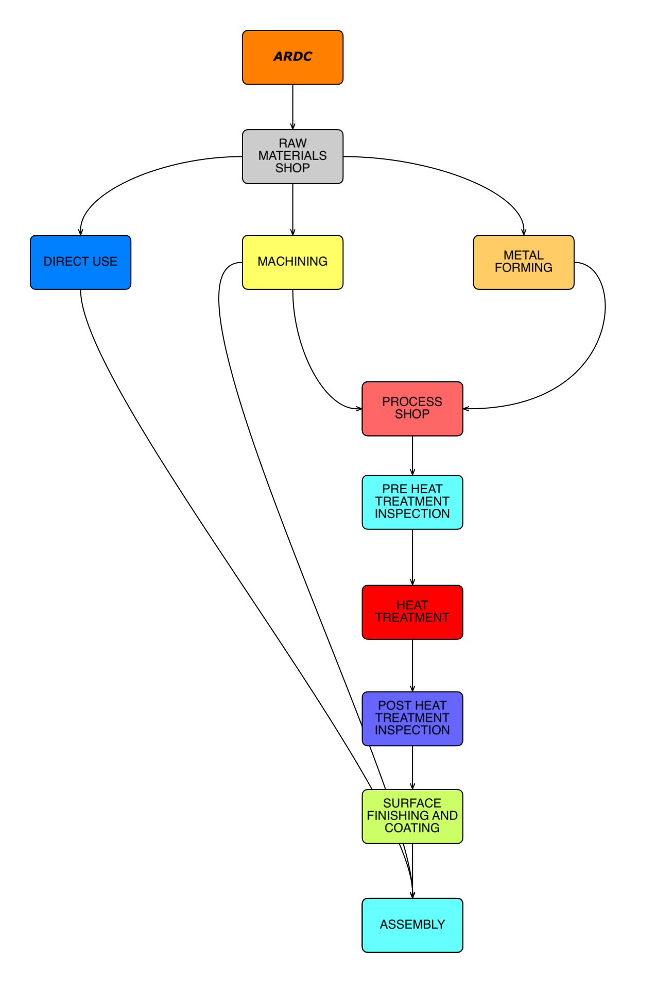

Flowchart of ARDC**HAL**

**FOUNDRY**

The HAL Foundry and Forge division is a well-established manufacturing and process unit. Many of the key components used in the indigenous aircraft find its root here. The foundry and forge division has many sub-divisions to improve production efficiency.

There is both ferrous and non-ferrous foundry. We visited the aluminum foundry where we saw a completely mechanized sand mold preparation line. The sand used is silica sand along with some binders. Sprues, runners and gates are present in the mold, which have their own significance. The riser is used to compensate the shrinkage that occurs during solidification.

We were shown the technique of investment casting. This involves the production of replica using special wax. Then the replica is dipped into a refractory slurry and then it is dried. The wax is then melted to get a mold of exactly same dimension of the replica. The hot metal is poured into the pre-heated mold and then cooled slowly. The mold is then broken to retrieve the cast product.

Traditional sand casting of magnesium is dangerous due to high volatile property of magnesium, hence it is carried out with great precaution. We were shown the mold design of the gearbox that is used in the ALH (Advanced Light Helicopter).

**FORGING**

Forging is usually done on metals which have good flow properties i.e. the metal should flow and attain the die shape. This operation is carried at high temperatures usually just below the recrystallization temperature. Mechanical press is used for forging of steel and titanium while hydraulic press is used for aluminum which requires slow pressing and gradual loading. Graphite is applied on the die before forging which aids in easy removal of the forged metal. This will be removed later by etching process.

There are different types of mechanical and hydraulic press which are classified according to their maximum load. Example, 300T, 500T, 1500T etc.

In counter blow hammer, both the die move simultaneously from top and bottom which ensures that highly intricate dimensions are achieved. In ring rolling the hot metal ring can be increased to required diameter by compressing and rolling.

Further both the cast and forged materials will be sent for heat treatment to achieve desired properties. After heat treatment the cast products will undergo NDT (radiography for casting and ultrasonic test for forging because of its smaller grain size).

